**Assignment 3.2**

1. Obtain the elements of the union between two character vectors.

vec1 = c(rownames(mtcars[1:15,]))

vec2 = c(rownames(mtcars[10:32,]))

union(vec1, vec2)

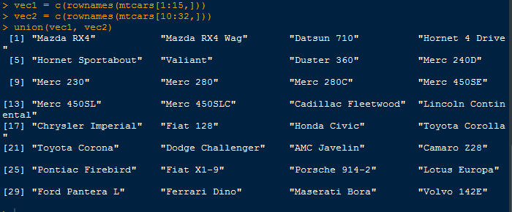

2. Get those elements that are common to both vectors.

vec1 = c(rownames(mtcars[1:15,]))

vec2 = c(rownames(mtcars[10:32,]))

intersect(vec1, vec2)

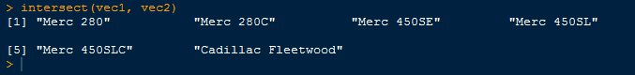

3. Get the difference of the elements between two character vectors.

vec1 = c(rownames(mtcars[1:15,]))

vec2 = c(rownames(mtcars[10:32,]))

setdiff(vec1, vec2)

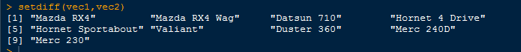

4. Test the quality of two character vectors.

vec1 = c(rownames(mtcars[1:15,]))

vec2 = c(rownames(mtcars[11:25,]))

setequal(vec1, vec2)

